Inventory Tracking System: UML Diagram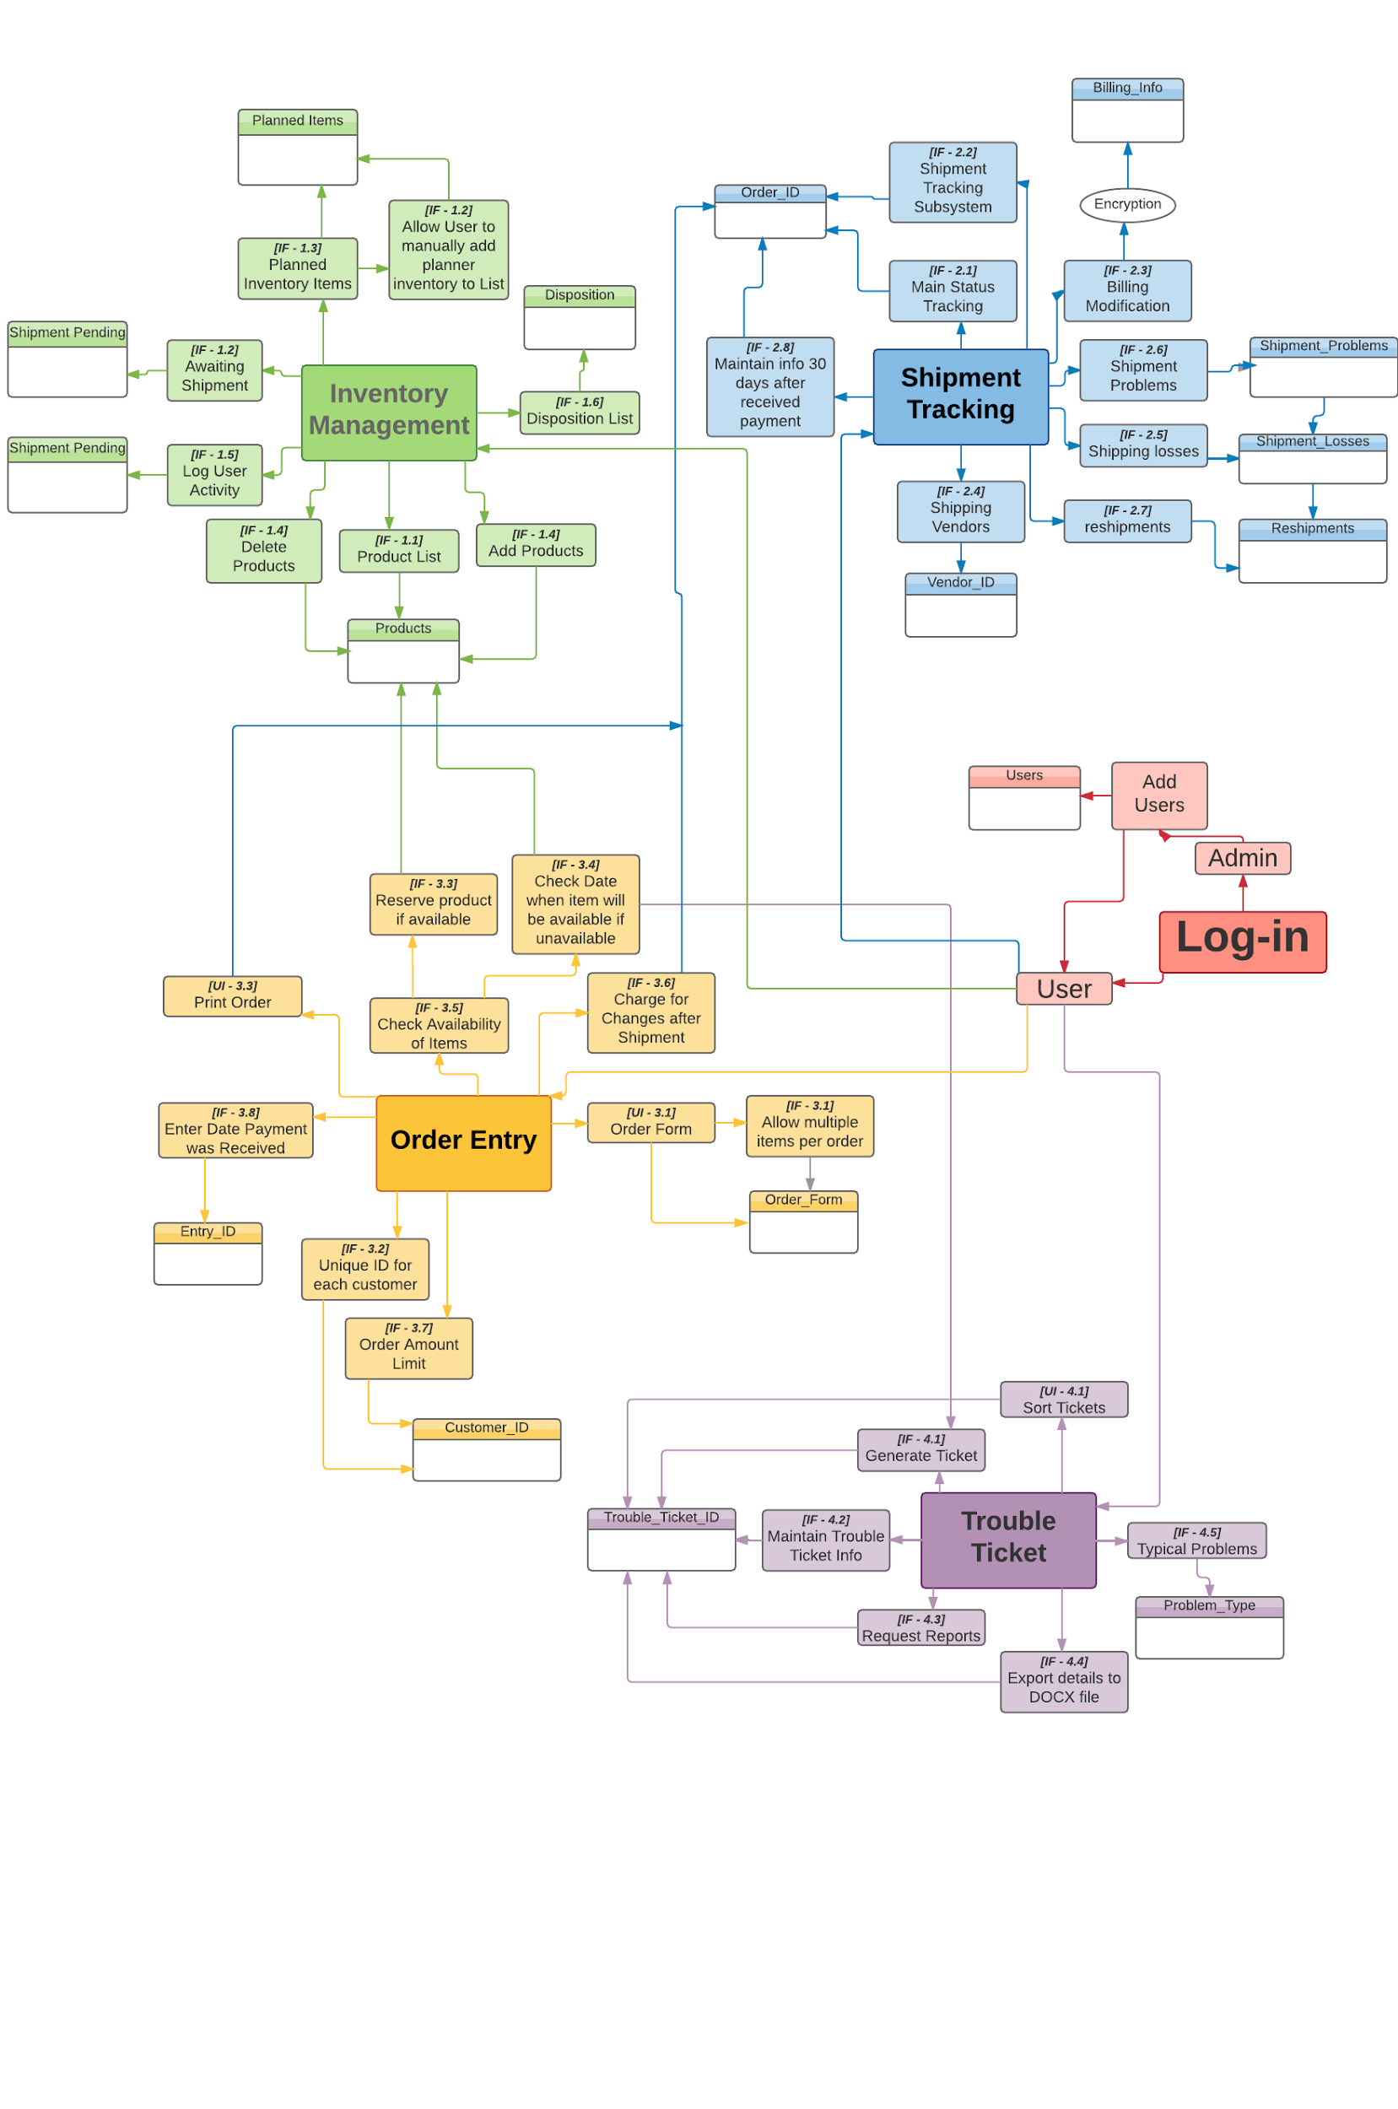

Inventory Tracking System: Component Diagram